

 | Name:  Id:  Program:  Subject: | Hanzala Ahmed  6194-2003419  BSCS  Compiler Constructor

Silent Data Corruptions

Abstract:
Silent Data Corruption (SDC) can have negative impact on large-scale infrastructure services. SDCs are not captured by error reporting mechanisms within a Central Processing Unit (CPU) and hence are not traceable at the hardware level. However, the data corruptions propagate across the stack and manifest as application-level problems. These types of errors can result in data loss and can require months of debug engineering time. In this paper, we describe common defect types observed in silicon manufacturing that leads to SDCs. We discuss a real-world example of silent data corruption within a datacenter application. We provide the debug flow followed to root-cause and triage faulty instructions within a CPU using a case study, as an illustration on how to debug this class of errors. We provide a high-level overview of the mitigations to reduce the risk of silent data corruptions within a large production fleet. In our large-scale infrastructure, we have run a vast library of silent error test scenarios across hundreds of thousands of machines in our fleet. This has resulted in hundreds of CPUs detected for these errors, showing that SDCs are a systemic issue across generations. We have monitored SDCs for a period longer than 18 months. Based on this experience, we determine that reducing silent data corruptions requires not only hardware resiliency and production detection mechanisms, but also robust fault-tolerant software architectures.

Introduction:
Every day, billions of people connect with each other through Meta using services like Facebook, Instagram, WhatsApp, and Messenger. Meta’s services rely on fleets of servers in data centers across the globe, all running applications and delivering the performance the services need. However, silent data corruption, or data errors that go undetected by the larger system, remain a widespread challenge for large-scale infrastructure systems. This type of corruption can propagate across the stack and manifest as application-level problems. It can also result in data loss and require months to debug and resolve. Our teams enable and support hardware testing and large-scale experiments in Meta's data centers including detecting and remediating silent data corruptions on a scale of hundreds of thousands of machines.

2 RELATED WORK
Previous work within the silent error domain studies the impact of soft errors due to radiation [11], and how environmental factors can lead to soft errors within the system. The study provides error rate observations for a non ECC protected SRAM. This is calculated using a Soft Error Rate (SER) from radiation resulting in an estimated 50000 FIT (Failure-In-Time: One FIT is equivalent to one failure in 1 billion device hours). Hence they recommend using ECC which reduces the error rate by 1000x for SRAMs.

3. DEFECT CATEGORIES
Each datacenter CPU contains billions of transistors which are switching constantly. These transistors are devices made of chemical compositions predominantly of silicon with p-type and n-type impurities. A CPU is designed to meet the desired computing requirements while keeping within the power, thermal and spatial constraints for the chip. Once the design is signed off, a layout for the chip is prepared where billions of logic gates are placed to minimize electrical noise, crosstalk, boost signal distribution and stability. Finally, after validation of all the functional, architectural, and physical requirements, the chip is taped-out as part of the chip development process. After the manufacturing process, the designed chips are then subject to test patterns for expected functional behavior, quality control and eventually shipped to all the computing customers worldwide.

3.1 Device Errors
Within the manufacturing and design process there are opportunities for defects to manifest. It is possible that the design has corner case scenarios. For example, a block which manages the cache controller under a particular power state can have functional limitations. This can result in the device being stuck or manifest functional errors.
3.2 Early Life Failures
Some of the early life failures are identified during manufacturing tests, these failures negatively impact the yield of the process. A few of the devices are healthy enough to pass the manufacturing test pattern but exhibit failure symptoms only after they have been in the field serving workloads. Depending on the type of electrical weakness within the transistor, a fault may manifest within the first weeks, months or any time before the end of the expected device life [10], [17]. These failures are classified as early life failures.
3.3 Degradation
It is also possible for the devices to get weaker with usage. A computational block used frequently can show wear and tear, and degrade
faster than the other parts of the CPU. These are uncommon in comparison to early life failures but are still observed within the industry. An example of this can be seen in another device used in servers.

3.4 End-of-Life Wear-out
When the device has been in the field serving workloads for a while, beyond their rated life, the entire silicon starts exhibiting wear-out [26], [20], [8]. This is observed in most components and is classified as silicon wear-out within the bathtub curve modeling of failures.
This is also typically the duration for which the failure analysis support or firmware support exists for CPUs.

4 APPLICATION LEVEL IMPACT OF SILENT CORRUPTIONS
Facebook infrastructure is made up of hundreds of thousands of servers and has billions of users accessing our applications. With billions of users accessing the Facebook family of applications, the infrastructure receives billions of requests per day. With billions of user queries, image uploads, and media content, the processing required for these applications needs to be fast, reliable, and secure.
We utilize fundamental concepts within distributed systems to partition our applications and optimize each of the said partitions. A typical application can require anywhere between tens of machines to hundreds of thousands of machines based on the complexity, resource profile and computing needs of the application. One such partition is our querying infrastructure. This querying infrastructure is used to fetch and execute SQL and SQL like queries (Presto,Hive, Spark) [5], [6] across multiple datasets.

4.1 Spark
Figure 1 [19] describes a typical architecture of a spark cluster. Spark is a widely known distributed processing framework which works based on the concept of Resilient Distributed Datasets (RDDs) each of which can be run in parallel.

4.2 FB Compression Application
Like wordcount, compression is a technique which is used to reduce the storage footprint of datastores and can make use of the spark architecture. There are multiple algorithms for compression. In this paper we will not be going into details of the algorithms.

5 DEBUGGING SILENT DATA CORRUPTIONS AT SCALE
With concerted debugging efforts and triage by multiple engineering teams, logging was enabled across all the individual worker machines at every step. This helped narrow down the host responsible for this issue. The host had clean system event logs and clean kernel logs. From a system health monitoring perspective, the machine showed no symptoms of failure. The machine sporadically produced corrupt results which returned zero when the expected results were non-zero

5.1 Tools
We need to perform language conversion while keeping reproducer consistency to triage the root-cause. In this example, we traverse from Scala language reproducer to Java reproducer to JIT compiled JBC to Assembly to triage the instruction level root-cause and enable the reproducer code. Unlike C and C++, Just-In-Time (JIT) compiled code is not compiled ahead of time. However, to debug a silent error, we cannot proceed forward without understanding which machine level instructions are executed. We either need an ahead-of-time compiler for Java and Scala or we need a probe, which upon execution of the JIT code, provides the list of instructions executed.

5.1.1.Scala to Java Byte Code.
The first step to get to assembly is to convert the reproducer from
Scala to Java.
5.1.2 GCJ.
GCJ [1] was an open source ahead-of-time compiler which could convert JBC to blobs of object files and binary. This binary can be used within GDB to debug.

5.1.3 HotSpot.
Java provides options to use +PrintAssembly to act as a probe and print assembly of the executed code with the use of HotSpot Profiling. To support +PrintAssembly, there are 2 requirements,
• Virtual machine with support for hotspot profiler
. Library for profiling
5.2 Best Practices for Silent Error Debug
A few guidelines while reverse engineering the printed assembly code. While these guidelines are derived from this example, they can be leveraged for debugging similar silent data corruptions.
• Absolute address references:
• Unintended branches
. External library references
. Compiler optimization
• Stub and Redundant Instructions
.Input/output registers
. Managing stack frames
. Memory-offsets references
. Special function units
. Main frames

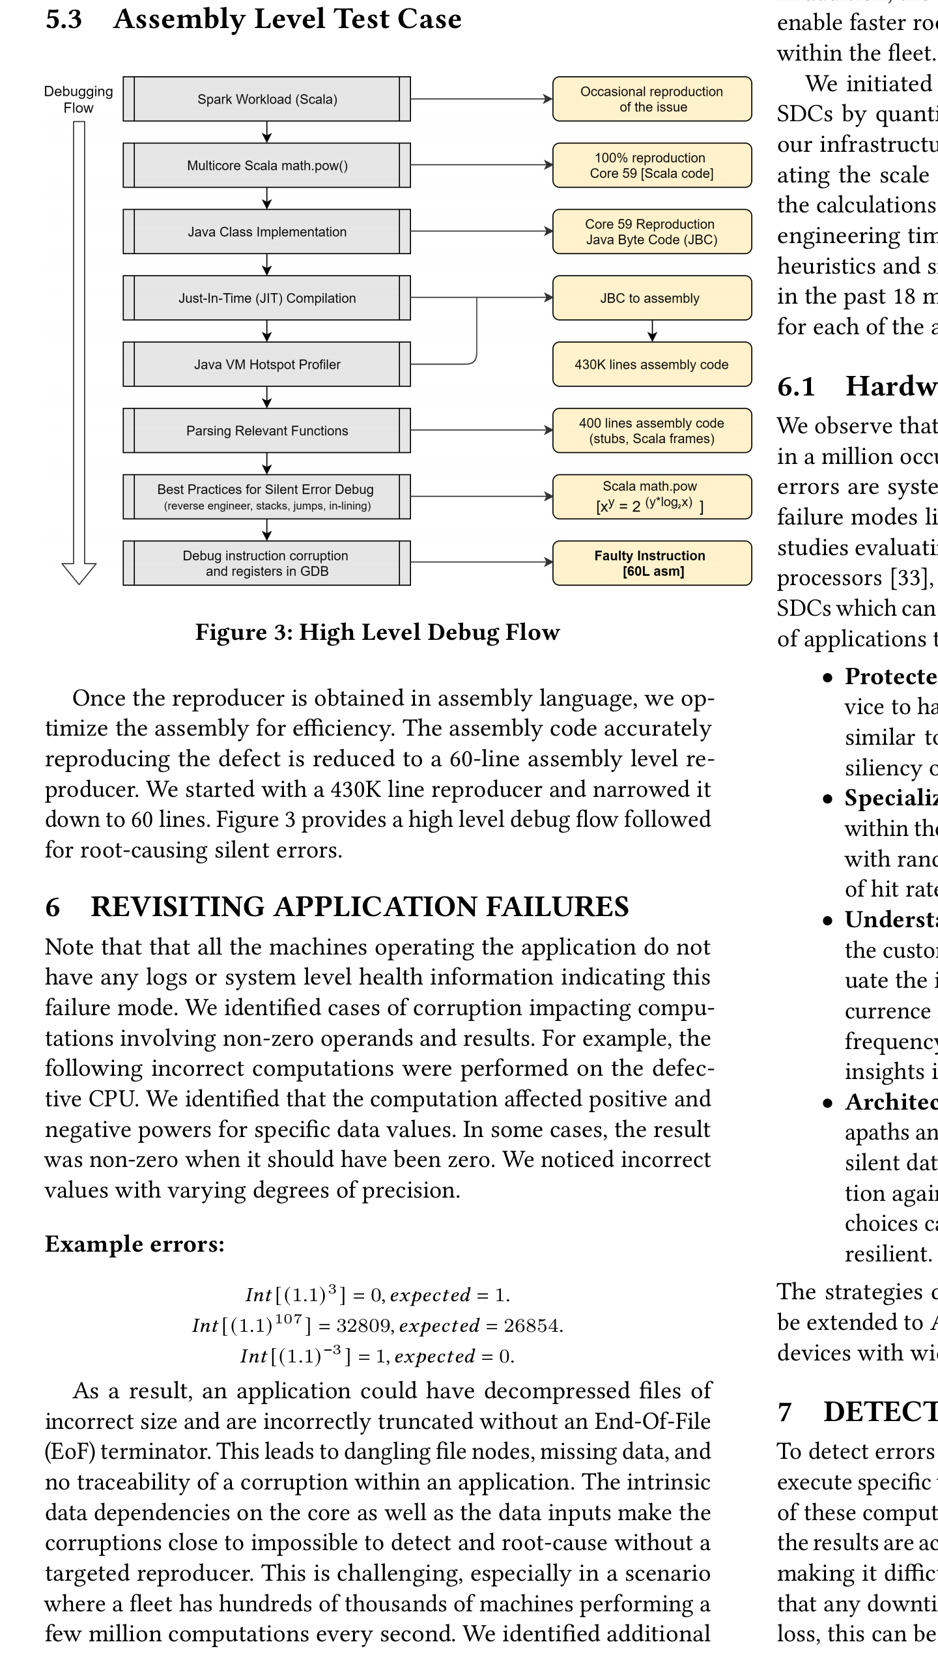
Once the reproducer is obtained in assembly language, we optimize the assembly for efficiency. The assembly code accurately reproducing the defect is reduced to a 60-line assembly level reproducer. We started with a 430K line reproducer and narrowed it down to 60 lines. Figure 3 provides a high level debug flow followed for root-causing silent errors.
Once the reproducer is obtained in assembly language, we optimize the assembly for efficiency. The assembly code accurately reproducing the defect is reduced to a 60-line assembly level reproducer. We started with a 430K line reproducer and narrowed it down to 60 lines. Figure 3 provides a high level debug flow followed for root-causing silent errors.
6 REVISITING APPLICATION FAILURES
Note that that all the machines operating the application do not have any logs or system level health information indicating this failure mode. We identified cases of corruption impacting computations involving non-zero operands and results. For example, the following incorrect computations were performed on the defective CPU. We identified that the computation affected positive and negative powers for specific data values. In some cases, the result was non-zero when it should have been zero.
7 DETECTION MECHANISMS
To detect errors of this type in the fleet, we need workloads which execute specific types of computations. We then compare the results of these computations with known reference values to ensure that the results are accurate. Silent corruptions tend to be data dependent making it difficult to predict their occurrence in the fleet. Given that any downtime for testing in a production fleet is an efficiency loss, this can be achieved in 3 different ways:
7.1 Opportunistic
Opportunistically utilize machines in maintenance states and perform instruction level accuracy validation with randomized data inputs.
7.2 Periodic
Implement a scheduler which periodically monitors machines for silent error coverage and then schedules machines based on a periodic timer (for example: 15 days) for testing. Here the overhead is high as the machine is forced to an out of production status to perform testing at a specified schedule.
7.3 Production Friendly
Tests can be optimized to be minimal in size and run-time. This can enable test instructions to be executed in parallel with the workloads on the machine
8 SOFTWARE FAULT TOLERANT MECHANISMS
To deal with silent errors, we need to rethink the robustness of infrastructure software design philosophies and software abstractions.
8.1 Redundancy
8.2 Fault Tolerant Libraries
9 CONCLUSIONS
Silent data corruptions are real phenomena in datacenter applications running at scale. We present an example here which illustrates one of the many scenarios that we encounter with these data dependent, reclusive and hard to debug errors. Understanding these corruptions helps us gain insights into the silicon device characteristics; through intricate instruction flows
and their interactions with compilers and software architectures. Multiple strategies of detection and mitigation exist, with each contributing additional cost and complexity into a large-scale datacenter infrastructure.
A better understanding of these corruptions has helped us evolve our software architecture to be more fault tolerant and resilient. Together these strategies allow us to mitigate the costs of data corruption at Facebook’s scale.

Reference
https://scholar.google.com/scholar?start=10&q=compiler+free+research+paper+on+2021,22&hl=en&as_sdt=0,5#d=gs_qabs&t=1652729128106&u=%23p%3D-dS773vFhv4J

